**Create AWS ELB with Self-Signed SSL Cert**

Self-signing SSL Cert

1. Generate self-sign certificate using this command:

openssl req -x509 -nodes -days 365 -newkey rsa:2048 -keyout privateKey.key -out certificate.crt

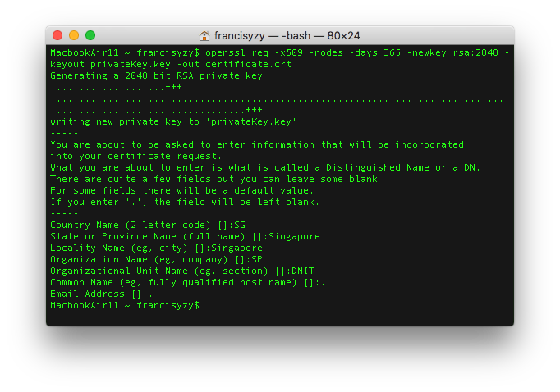

Generating certificate

2. Verify the key and certificate generated

*openssl rsa -in privateKey.key -checkopenssl x509 -in certificate.crt -text -noout*

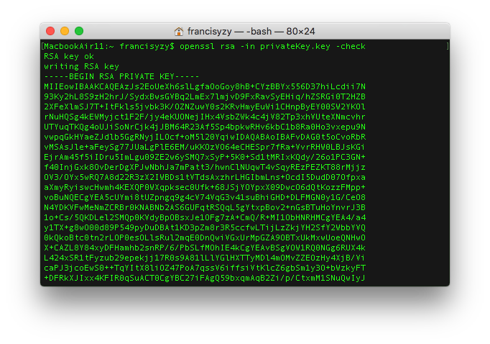

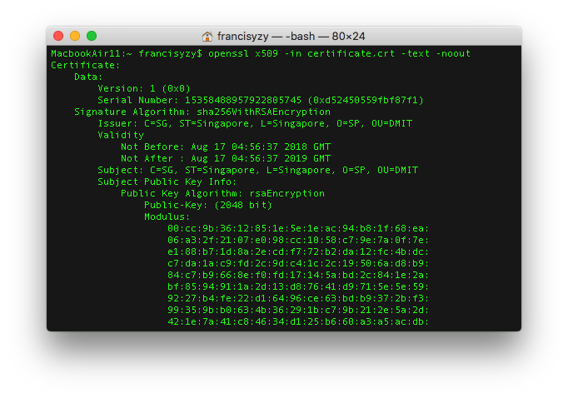

3. Convert the key and cert into .pem encoded file

*openssl rsa -in privateKey.key -text > private.pemopenssl x509 -inform PEM -in certificate.crt > public.pem*

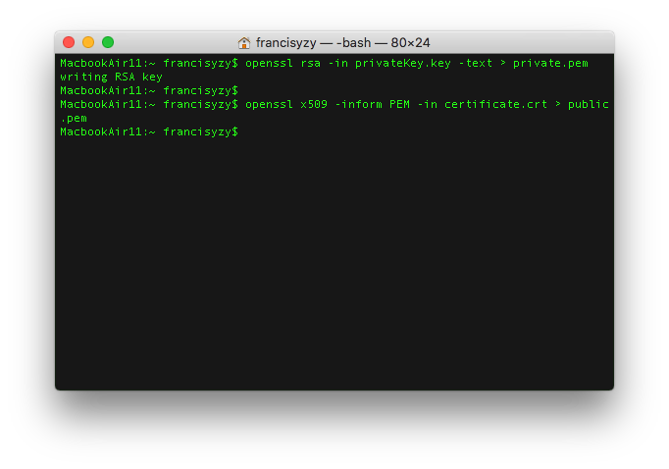

Create Elastic Load Balancer using AWS Console

Sign into [AWS Console](http://console.aws.amazon.com/) and head to EC2 dashboard

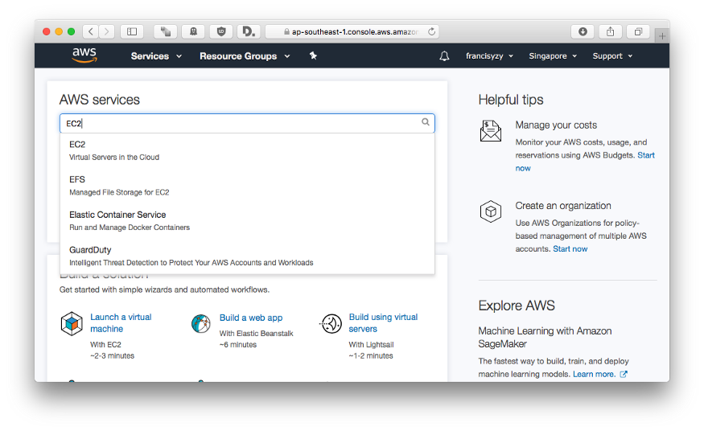

Go to load balancer and click Create Load Balancer

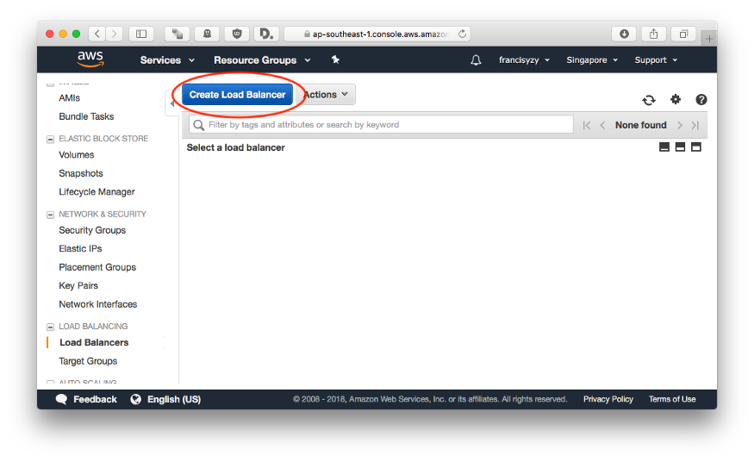

Select Application Load Balancer

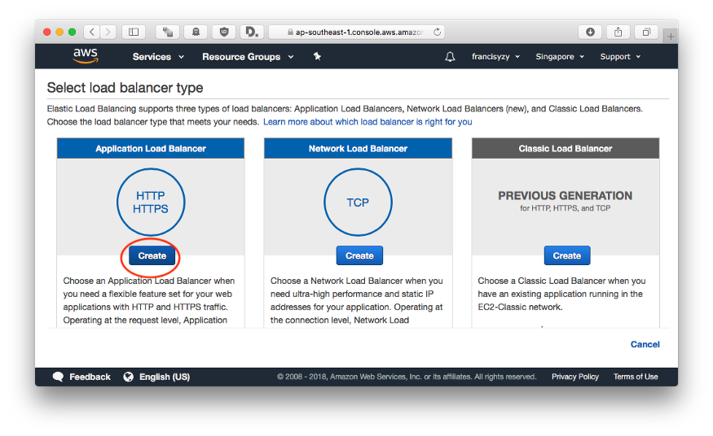

Configure Load balancer

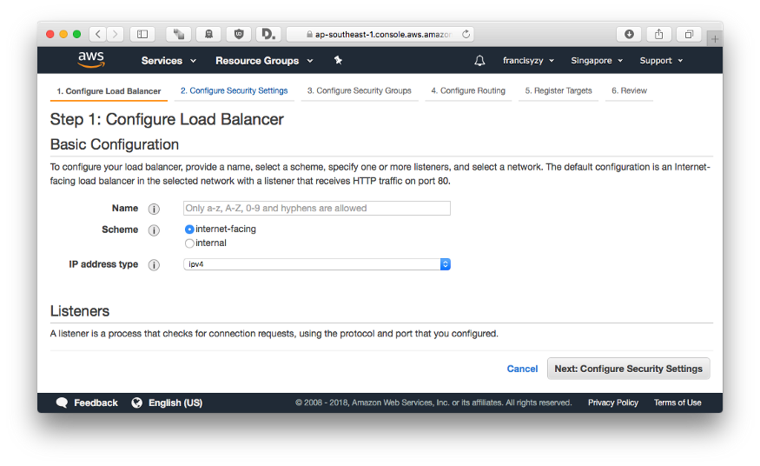

Add new HTTPS Listener

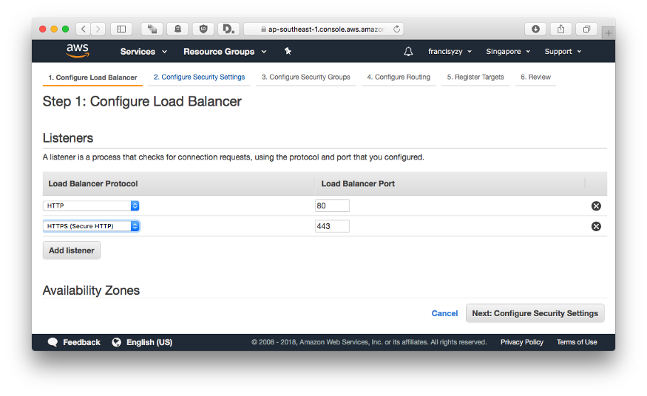

Using PEM Generated in Self-Signing SSL Cert

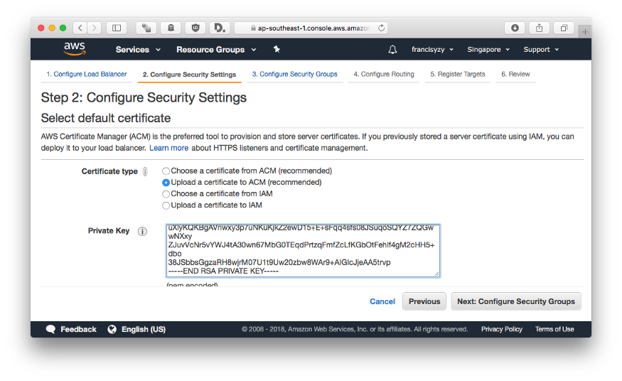

Create new security group for new ELB

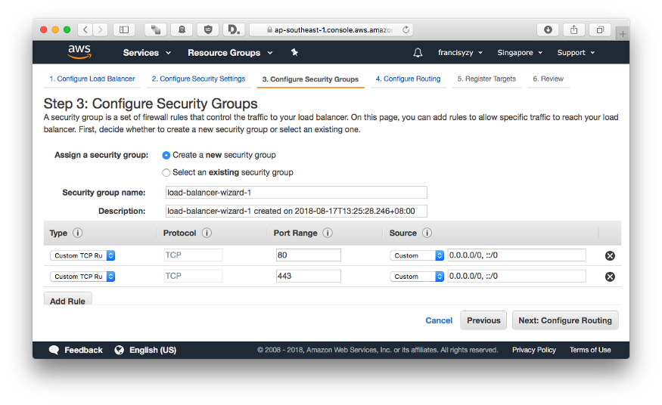

Add internal routing using HTTP

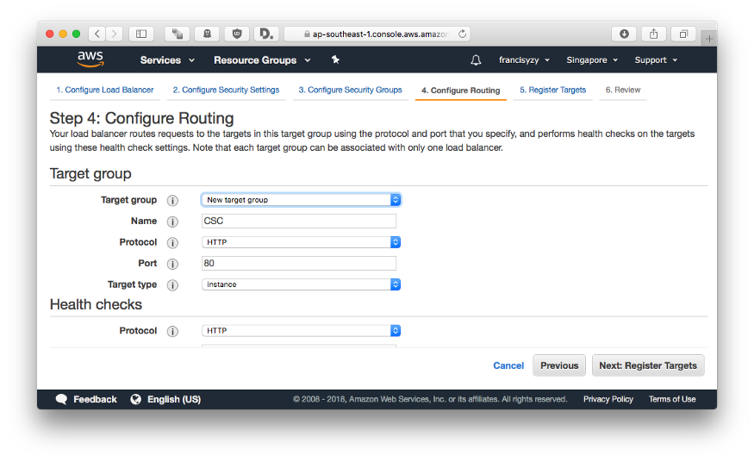

Register targets

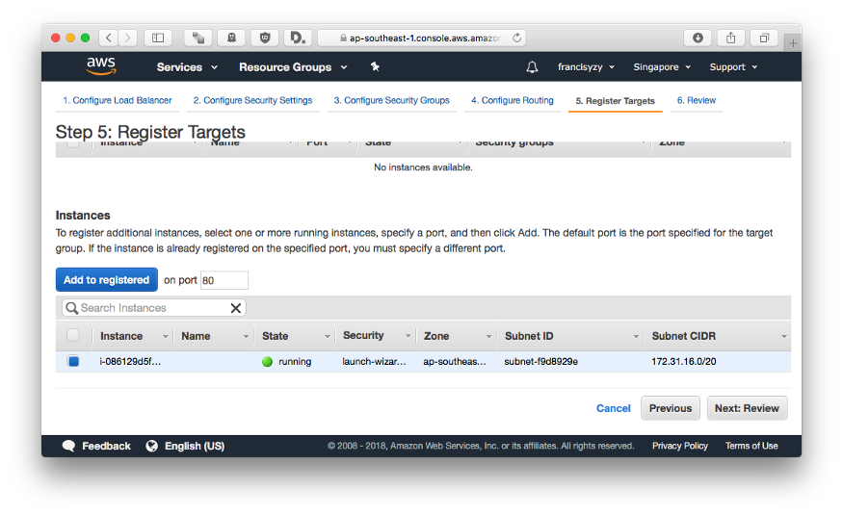

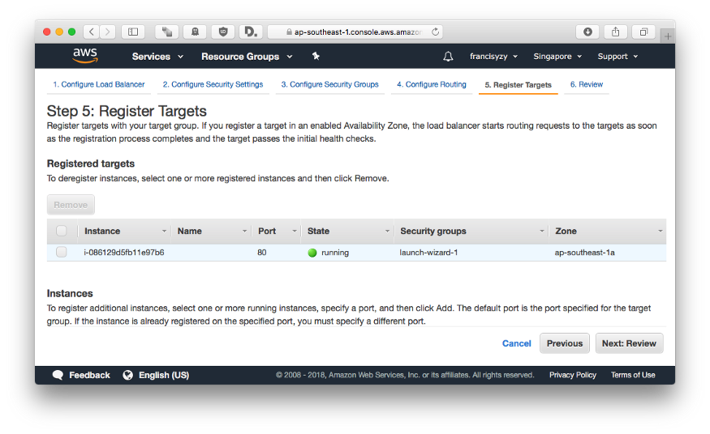

Review and create ELB

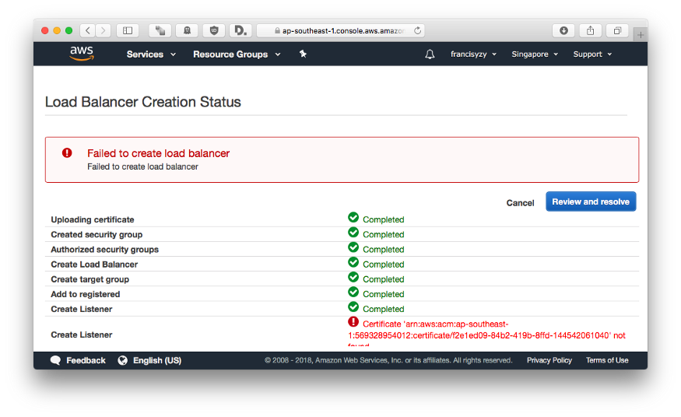

Error will occur because certificate uploaded via GUI cannot be found.

Uploading certificate via CLI

Install [AWS CLI](https://docs.aws.amazon.com/cli/latest/userguide/installing.html)

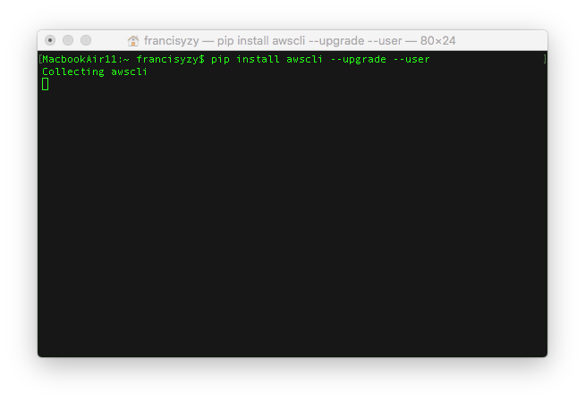

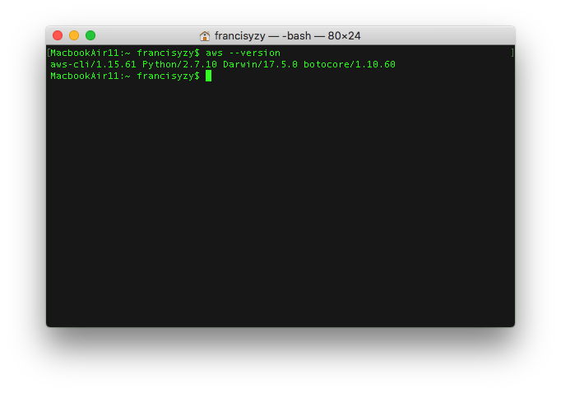

Get AWS Access Keys

Go to IAM Dashboard

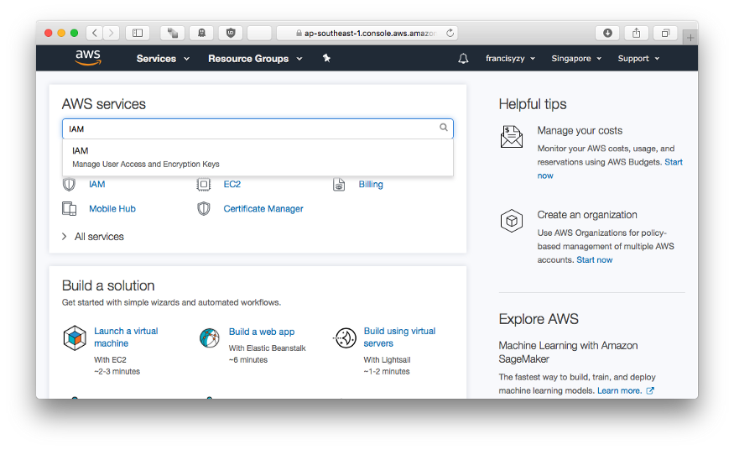

Find your user and create access key

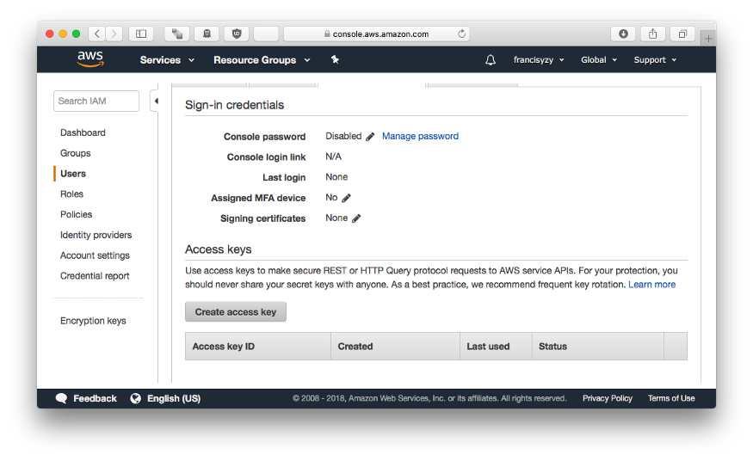

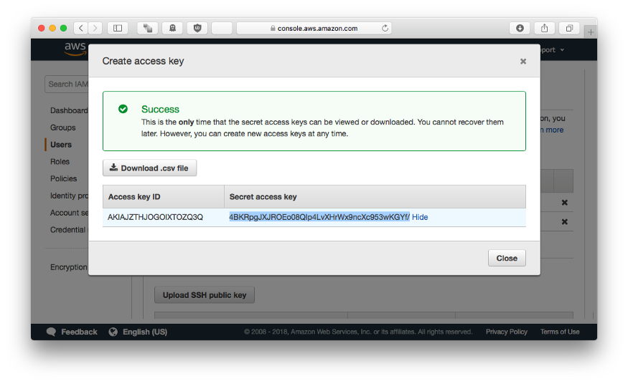

[Configure AWS CLI](https://docs.aws.amazon.com/cli/latest/userguide/cli-chap-getting-started.html)

Enter your Access Key ID

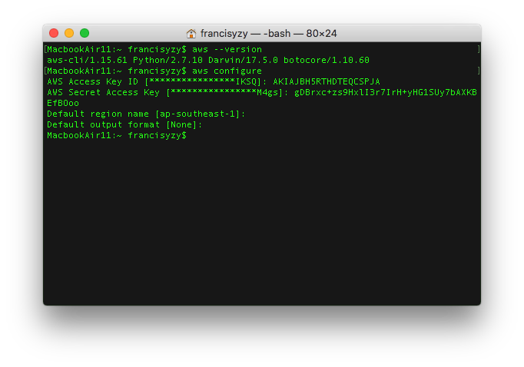

[Upload the Certificate using AWS IAM CLI](https://docs.aws.amazon.com/cli/latest/reference/iam/upload-server-certificate.html)

Enter the following command with the correct pathing to the Key and Certificate. Server certificate name is user defined.

aws iam upload-server-certificate --server-certificate-name CSC --certificate-body file://public.pem --private-key file://private.pem

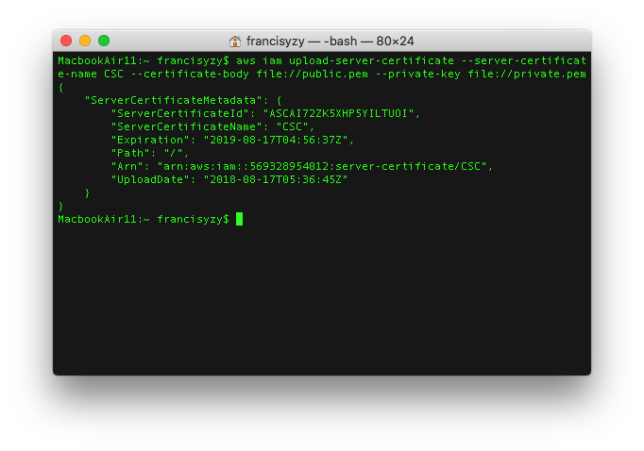

Create Elastic Load Balancer using AWS Console pt2

Go to 2. Configure Security Settings and choose the new certificate uploaded.

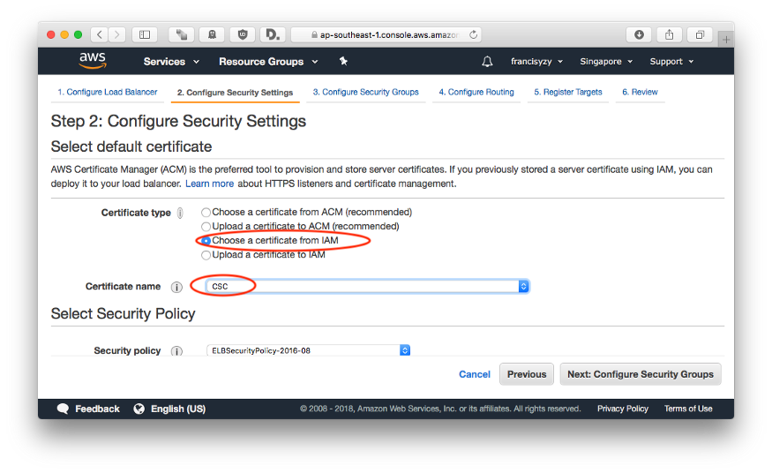

Skip to review and create the ELB

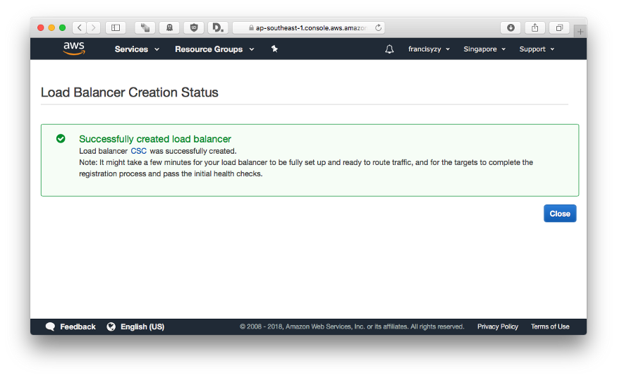

Wait for the ELB to change State

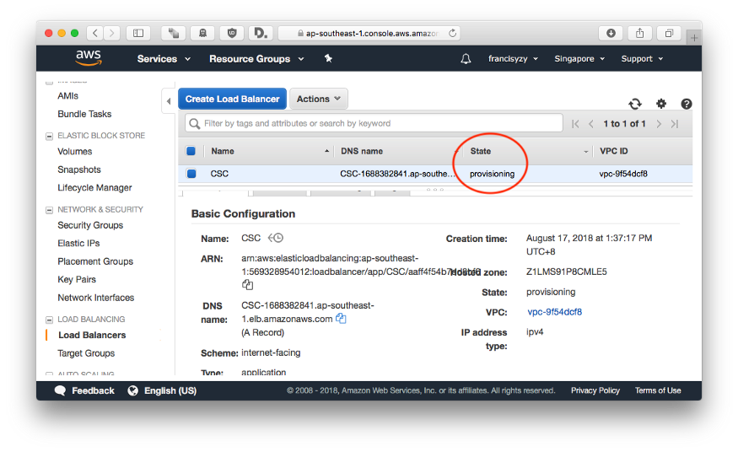

Copy the DNS Name to test it out.

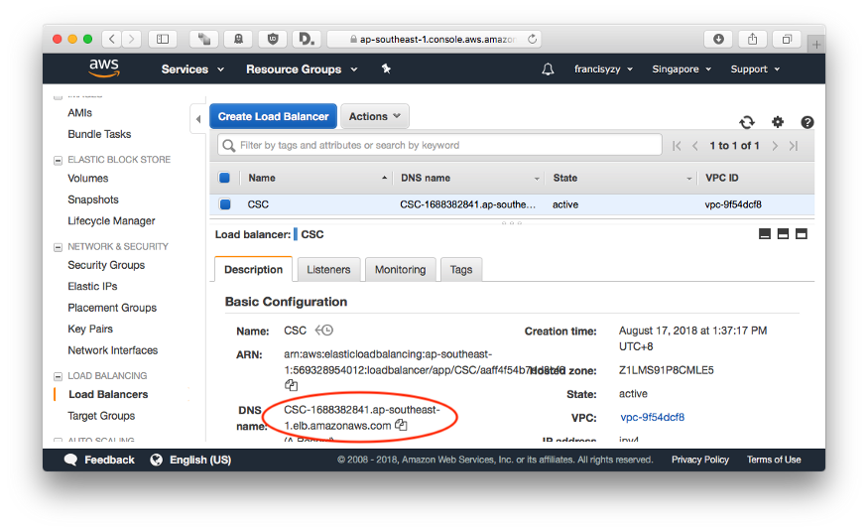

Testing

Original EC2 Instance

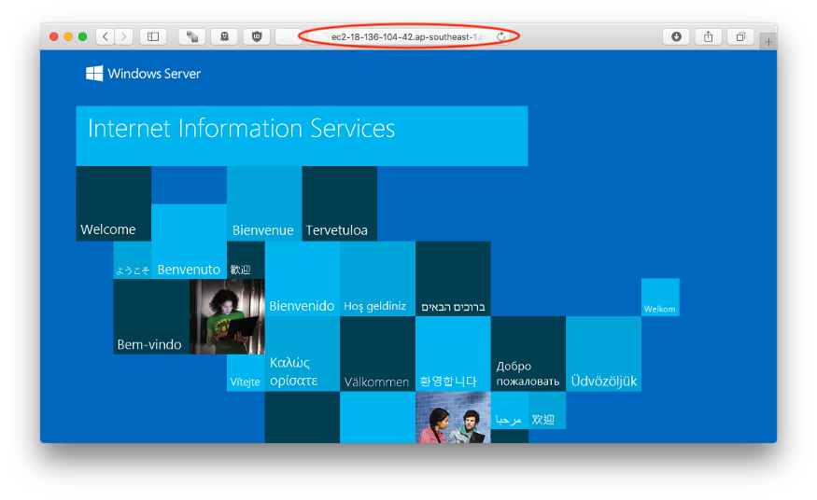

ELB Connection

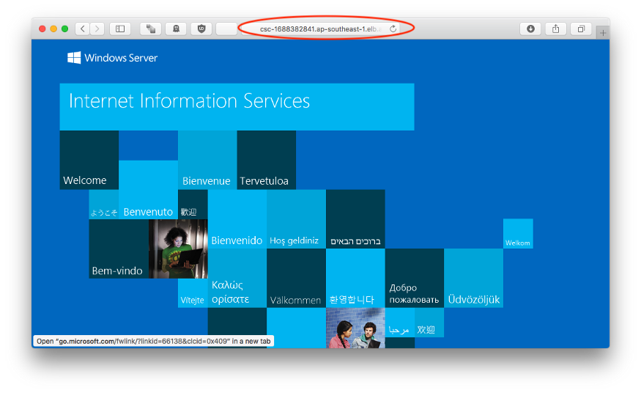

ELB w/ HTTPs

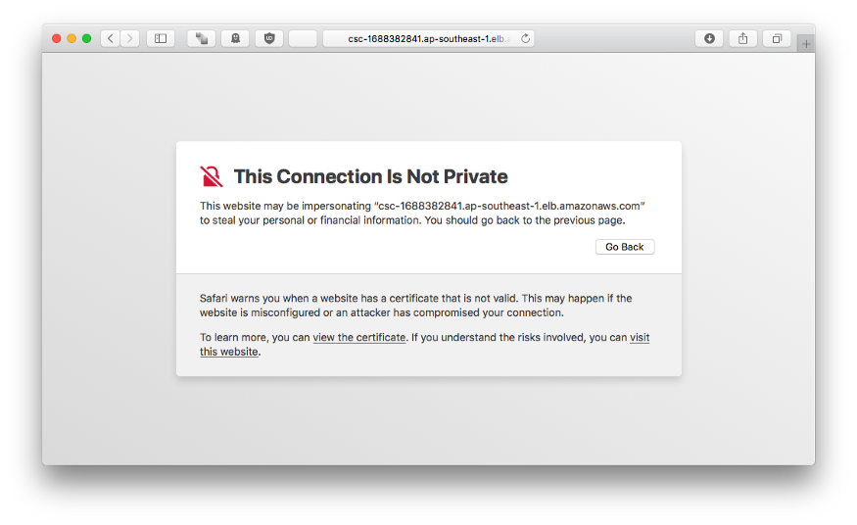

As this is a self signed certificate, the browser will warn.

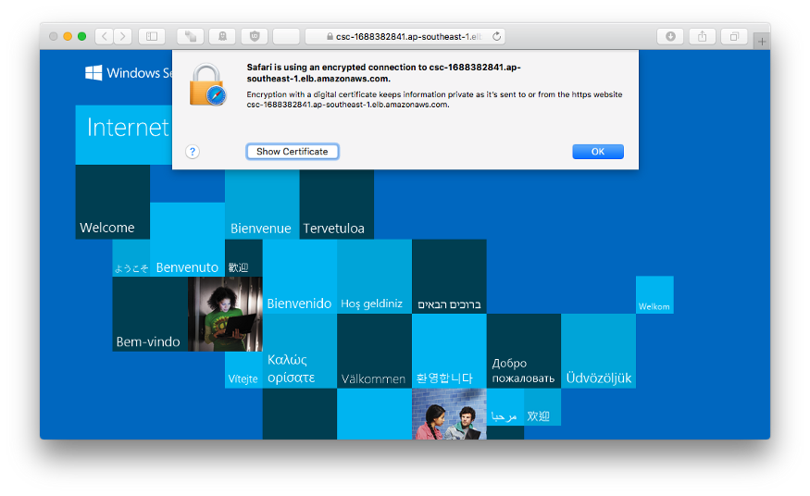

Secured connection to ELB

EC2 w/HTTPS will not work as the SSL cert is tied to the ELB and not the EC2.

